ANEXO TÉCNICO
mantenimiento tecnico del sna server
VERSION EN INGLES POR MICROSOFT

SNA Server Maintenance

This chapter introduces some of the SNA Server management, tracking, and troubleshooting tools and describes how each can be used for SNA Server maintenance. The following SNA Server management tools are described:
• | NVAlert and NVRuncmd services—These services are used to provide maintenance information to the host's NetView management software, as well as to allow NetView operators to execute Windows NT commands from the NetView console.
• | Windows NT event logging—This tool can be used for maintenance of all aspects of SNA Server. SNA Server and its services constantly log information to the event log subsystem in order to provide information regarding its function. This information can be informative, or it may describe an impending problem or provide the troubleshooting information required for resolving an existing problem.
• | Pop-up message—SNA Server is also capable of displaying pop-up messages in order to convey a maintenance-related message to the SNA Server administrator. Pop-up messages from multiple SNA Servers can be routed to a single Windows NT computer for easier administration.
• | SnaRas service—This service provides a means by which SNA Server administrators can use client/server protocols over an SNA protocol link. This can be useful when managing remote SNA Servers.
• | Snacfg utility—This command-line utility allows SNA Server administrators to configure SNA Server from the command line as opposed to using the SNA Server manager. Even though it is recommended that you use the SNA Server manager for configuration, this tool can be very useful in certain circumstances.
The chapter also describes some of the tools that can be used to gauge SNA Server performance and some of the ways to configure SNA Server to improve performance. The following topics are discussed:
• | Performance Monitor—This is a Windows NT tool that can be used to track almost all aspects of Windows NT performance, as well as SNA Server performance. This can be very useful when establishing an SNA Server performance baseline or when trying to locate a performance problem.
• | Response Time Monitor (RTM)—This tool allows you to measure host response times, including both the time required for an SNA Server client's message to reach the host and for the host to respond.
• | Multinode support—SNA Server allows you to configure as many as four SNA Server services for each SNA Server installation. This is sort of like running four copies of SNA Server on one computer. This can help in two ways. First, it increases—by a factor of four, if that many services are running—the number of LUs and other resources that can be configured on SNA Server. Second, it can provide a performance improvement by dividing SNA Server functions over as many as four different SNA Services that all have equal priority access to system resources.
• | Data compression—This SNA Server capability can be employed with many of the SNA Server configurations. Compressing SNA Server data prior to transmission aids in conserving network bandwidth, although it does demand more time and resources from the local computers that compress and decompress data before it is transmitted or consumed.
Other performance considerations, such as the size of the basic transmission unit (BTU) are also described.
Finally, this chapter describes some of the tools and techniques that can be used to troubleshoot SNA Server faults. You will learn about some of the problems that could arise in SNA Server-to-host communications, SNA Server-to-SNA Server communications, and SNA Server client-to-SNA Server communications and how tools such as SNA tracing can be used to resolve some of these problems.

On This Page
Managing SNA Server
Integrating SNA Server with Host Management Software
Logging Events with NVAlert
Managing the SNA Server Using NVRuncmd
Logging SNA Server Events
Installing and Configuring SnaRas
Snacfg Syntax
Using a Command File with Snacfg
Study Break
Tracking and Improving SNA Server Performance
Configuring the Basic Transmission Unit (BTU) Length
Configuring the Pacing Values
Configuring the Request/Response Unit size
Study Break
Study Break
Summary

Managing SNA Server
Although configuring SNA Server can involve lots of work for SNA Server administrators, unfortunately, the work does not stop at configuration. After proper configuration, SNA Server administrators must use the proper management techniques and tools to ensure proper SNA Server functionality on a daily basis. Recall that in most environments SNA Server is a particularly important software application because it forms the bridge that allows clients to access some of the organization's most mission-critical data. SNA Server administrators can take advantage of the following management features that can be used to manage SNA Server functions:
• | NVAlert and NVRuncmd services—These services are used to provide maintenance information to the host's NetView management software, as well as allow NetView operators to execute Windows NT commands from the NetView console.
• | Windows NT event logging—This tool can be used with all aspects of SNA Server maintenance. SNA Server and its services constantly log information to the event log subsystem in order to provide information regarding its function. This information can be informative, or it may also describe an impending problem or provide troubleshooting information required for resolving an existing problem.
• | Pop-up message—SNA Server is also capable of displaying pop-up messages in order to convey a maintenance-related message to the SNA Server administrator. Pop-up messages from multiple SNA Servers can be routed to a single Windows NT computer for easier administration.
• | SnaRas service—This service provides a means by which SNA Server administrators can use client/server protocols over an SNA protocol link. This can be useful when managing remote SNA Servers.
• | Snacfg utility—This command-line utility allows SNA Server administrators to configure SNA Server from the command line as opposed to using the SNA Server manager. Even though it is recommended that you use the SNA Server manager for configuration, this tool can be very useful in certain circumstances.
This section describes these management features and how they can be used to properly manage an SNA Server environment.
Top of page

Integrating SNA Server with Host Management Software
NetView is a product used to monitor and manage devices on an SNA network. This software is typically installed on IBM mainframe computers. Traditional SNA devices, such as cluster controllers, are typically equipped with the necessary software that allows them to interface with the NetView management software in order to provide it with management information, as well as to allow the NetView operators to manage the cluster controller's functions. SNA devices that are equipped with the necessary NetView interface software are able to notify the NetView software of any system alerts, error conditions, or changes in the device configuration. This also allows SNA administrators to configure and manage the devices through the NetView console.
In NetView environments, there is at least one terminal that is used to view NetView messages and to manage devices through NetView. This terminal is known as the NetView console. It is common practice to have at least one NetView operator sitting at the NetView console at all times.
As you've learned, an SNA Server can replace typical SNA devices, such as cluster controllers. For NetView operators, it is very important that they still be able to log error conditions and manage this new device, the SNA Server. To accomplish NetView integration, SNA Server uses two services, called NVAlert and NVRuncmd. Let's take a closer look at how each of these services works.
Top of page

Logging Events with NVAlert
The NVAlert service is a Windows NT service that is automatically installed every time SNA Server is installed. NVAlert is used to forward SNA Server alerts to the NetView Console. The NVAlert service is able to read all events that are logged to NT's event logging service. It then determines whether the logged event is intended for forwarding to the NetView console. If it is, the event is forwarded to the NetView console, as shown in Figure 13.1.
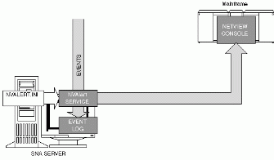
Figure 13.1: How the NVAlert Service Works. The NVAlert service can send NT Server events to the NETVIEW console. To specify the events to be forwarded, you muts modify the NVALERT.INI file.
See full-sized image.
NVAlert determines which events to forward to the NetView Console by using a file called NVAlert.ini. The NVAlert.ini is a text file that contains the information specifying which alert events to forward to the NetView console. A default copy of the NVAlert.ini file is copied to the System subdirectory of the SNA Server root directory when SNA Server is installed. The NVAlert.ini dictates which events are forwarded to the NetView console by specifying that event's information in an NVAlert.ini entry. A typical NVAlert.ini entry reads as follows,
[Source.Type.eventid]
Alerttype = xxxxx
Alert Description = xxxxx
Probable Causes = xxxxx
The first line of an NVAlert.ini entry, which includes the source, type, and eventID as shown above, identifies the event to be forwarded. This information is gathered from Windows NT's event viewer program. We'll provide more information on the event viewer later in this chapter. The rest of the information that appears in an NVAlert.ini entry, such as Alert type or Alert Description, is NetView-specific information. You need to work with the NetView console operator or consult the IBM NetView documentation to determine the proper NetView-specific information to enter.
Once the NVAlert.ini is configured to forward the proper events to the NetView console, you need to specify which SNA Server connection will be used to carry NVAlert event data to the host. To configure the NetView connection, you must perform the following steps on the SNA Server Manager:
1. | Configure a link service and connection to the host where the NetView software is configured. The connection must have a Remote End of Host.
2. | Select the subdomain, and then on the View menu, click Properties. The Subdomain Properties window appears.
3. | Verify that the NetView tab is selected, as shown in Figure 13.2. In the NetView tab, you must select the proper connection from the pull-down box labeled Send NetView Management Data to this Connection. Only connections that are configured with a Remote End of Host will appear in the pull-down box. Click OK to configure the NetView connection.  After selecting the proper events to forward and the connection on which to forward them, the only thing left to do is to assure that the NVAlert service is started. By default, the NVAlert service is configured as Manual in the Control Panel, Services window. This means that the NetView service only starts when an SNA Server manually starts the service. If you will be using NVAlert consistently, it is recommended that you configure the service as Automatic. This means that the service will start every time Windows NT is started. To configure the NVAlert service to start automatically you must complete the following steps:
4. | On the Start menu, point to Settings, and then select Control Panel. The Control Panel window appears.  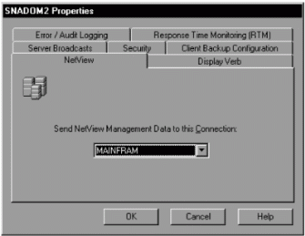  Figure 13.2: Subdomain Properties, NetView Window.  See full-sized image.
5. | Open the Service window by double–clicking the Services icon. The Services window appears.
6. | Select the NVAlert service and click the Startup button. The Service window appears, as shown in Figure 13.3.  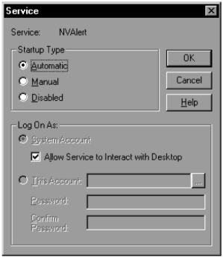  Figure 13.3: The Service Window.
7. | Select Automatic in the Startup box, and then click OK to configure the service to start automatically.
From this point on, the NVAlert service will start every time the Windows NT computer is started and it will automatically forward alert information to the NetView console.
Top of page

Managing the SNA Server Using NVRuncmd
The NVAlert service allows information to be sent to the NetView console. However, as you might have imagined, any NetView console operator that receives significant event information may want to be able to access the SNA Server in order to take some action that might be needed to solve a problem. This is precisely what the NVRuncmd service allows. The NVRuncmd service serves as an intermediary link between the NetView console and the Windows NT command line. A NetView console operator can specify a command to be run at the Windows NT Server command line. The NVRuncmd service then initiates the processing of the command at the Windows NT command line and returns the necessary output to the NetView console, as shown in Figure 13.4.
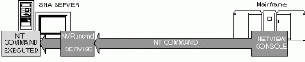
Figure 13.4: How the NVRuncmd Service Works. A NETVIEW operator can use the NVRuncmd service to execute NT commands on the SNA Server.
See full-sized image.
To execute a Windows NT command from the NetView console, a NetView console operator must use the following syntax at the NetView console:
runcmd sp=[servicepoint], appl=NVRuncmd cmd [commandname] [parameters]
You can substitute the servicepoint parameter with the control point name of the SNA Server. The commandname parameter allows you to enter any command that can be executed on a Windows NT Server. You can also use any parameters with the specified command. The following is an example of a typical NetView console command:
runcmd sp=SNASERV1, appl=NVRuncmd cmd DIR c:\SNA /W
This command will display the contents of the c:\SNA directory in a wide list format (/w).
Because a NetView console is substantially different from a PC server running Windows NT software, there are some significant limitations as to what tasks can be accomplished from a NetView console. The following rules apply when using the NVRuncmd service.
• | All commands specified by the NetView console operator must be commands that can execute on the Windows NT command line.
• | Only alphanumeric characters can be sent back to the NetView console. No graphical content can be sent to the NetView console.
• | Confirmation prompts are not returned to the NetView console. For example, if you typed DEL *.* at a command prompt, a confirmation prompt would appear asking if you were sure you wanted to delete the files and requesting that you type the letter Y for confirmation. The NVRuncmd service would not allow the console operator to enter Y for such a prompt.
• | Command parameters can be used. For example, you may choose to enter the DEL *.* command followed by the /Y parameter. In this case, the Y is already included in the initial command so that no confirmation prompt is required. This guarantees that files are erased.
• | NVRuncmd can only process one command at a time. Any commands sent while another is processing will be rejected by the NVRuncmd service.
The NVRuncmd service can be very useful when used in conjunction with the Snacfg command-line utility to configure SNA Server. We provide more information on this utility later in this chapter.
It is common for organizations to use the NVAlert service in order to receive immediate error logs from the SNA Server, but console operators typically refer the issue to the SNA Server administrator instead of using the NVRuncmd service to solve the problem.
Like the NVAlert service, the NVRuncmd is started manually, by default. To configure the NVRuncmd service to start automatically, perform the following steps:
1. | On the Start menu, point to Settings, and then select Control Panel. The Control Panel window appears.
2. | Open the Service window by double–clicking the Services icon. The Services window appears.
3. | Select the NVRuncmd service, and then click the Startup button. The Service window appears.
4. | Select Automatic in the Startup box, and then click OK to configure the service to start automatically.
From this point on, the NVAlert service will start every time the Windows NT computer is started and it will automatically forward alert information to the NetView console.
Top of page

Logging SNA Server Events
The Windows NT's event viewer is a very useful tool that can be used to determine SNA Server status, gather information used for troubleshooting SNA Server error conditions, and collect SNA Server audit information. Figure 13.5 displays a typical event viewer window. By default, each SNA Server installation logs its alert events to the event viewer logs. The Windows NT event log subsystem logs all its events to one of the following three log files:
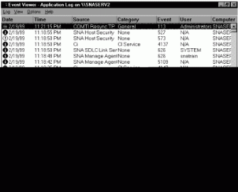
Figure 13.5: Event Viewer Window.
See full-sized image.
• | System log—This log records events pertaining to the Windows NT server operating system and the computer on which it is installed, such as disk drive capacity, processor performance, or failed services. Even though most SNA Server-specific events are not recorded in this log, the information found in this log is still very important with regard to proper Windows NT functionality and is therefore important to SNA Server.
• | Application log—This log records events pertaining to application software installed on the Windows NT Server. SNA Server records most of its events to this log.
• | Security log—This log records events pertaining to security access. Specifically with regard to SNA Server, this log records access to the configuration file.
The information contained in these event log files is very useful for SNA Server problem determination. Sometimes you may be asked to send a copy of the event log files to a support technician. The event logs are stored in the WindowsNTRoot\System32\Config directory and are named AppEvent.Evt for the application log, SysEvent.Evt for the system log, and SecEvent.Evt for the security log.
SNA Server can be configured to log most of its functions and error conditions to the event viewer or it can be configured not to log anything. Neither of these two extremes is very useful. Excessive logging can decrease system performance, while no logging at all could make it impossible to maintain proper status information on the SNA Server or to troubleshoot error conditions. As an SNA Server administrator, you can control which SNA Server events are logged to the event viewer by configuring the event logging setting on the SNA Server Manager. To configure this, perform the following steps:
1. | Access the subdomain properties by selecting the subdomain and clicking Properties on the View Menu. The Subdomain Properties window appears.
2. | Select the Error/Audit Logging tab, as shown in Figure 13.6. You must configure the properties defined in Table 13.1.
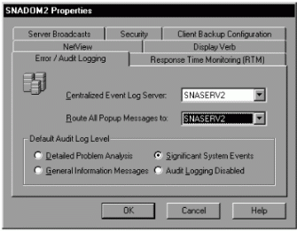
Figure 13.6: Subdomain Properties, Error/Audit Logging Tab.
See full-sized image.
Table 13.1 Subdomain Properties, Error/Audit Logging Tab
Property | Definition
Centralized Event Log Server | By default, each SNA Server installation logs its events to the event log subsystem of the Windows NT Server on which it is installed. This forces SNA Server administrators to check each of the SNA Server's event logs separately. Configuring this SNA Server property allows SNA Server events to be logged to a centralized event log subsystem. This means that you can configure all the SNA Servers in a subdomain to log their events to a specific SNA Server computer in the subdomain. You can then view the events logged for every SNA Server computer in the subdomain by simply accessing the event log subsystem of the centralized event log server.
Route All Pop-up Messages To | During SNA Server operation, certain pop-up messages may appear at the SNA Server computer. These pop-up messages typically alert administrators to some sort of error condition on the SNA Server computer. Like event viewer alerts, pop-up messages can be sent to a centralized server. This allows the SNA Server administrator to check for any error conditions on any of the SNA Servers in a subdomain by monitoring a single SNA Server.
Default Audit Log level | You can configure the amount of logging that SNA Server does by selecting one of the options in this box.
Detailed Problem Analysis | When this option is selected, all events that can be recorded are recorded. This includes all sorts of events, such as every time a user accesses an LU on SNA Server or every time the configuration file is accessed. That much logging is typically unnecessary, but it may be useful in certain situations.
Significant System Events | When this option is selected, only major events are logged. This is the default setting.
Audit Logging Disabled | Selecting this option effectively disables SNA Server event logging, although critical system events will continue to be logged.
A single SnaRas port supports only one SnaRas client.
Even though the SNA Server computers in a subdomain may be configured to route pop-up messages to a centralized server, the pop-up messages still appear on the local computer as well.

Managing SNA Server Using SnaRas
Managing and configuring SNA Server is typically accomplished by using the SNA Server manager. The SNA Server manager provides the graphical interface for manipulating the SNA Server resource configurations that are stored in the COM.CFG file. All that is required for using the SNA Server manager to configure the SNA Server subdomain is for the SNA Server manager to obtain access to the subdomain's COM.CFG file. One way to obtain access to the COM.CFG file is by simply using the SNA Server manager at the SNA Server primary configuration server (PCS). Another way is by using the SNA Server manager at any Windows NT computer that can access the PCS's COM.CFG file using a client/server protocol such as TCP/IP, NetBEUI, IPX/SPX, or Banyan Vines IP. But what if the Windows NT computer on which SNA Server Manager is running can't access the COM.CFG file over client/server protocols. This is true in cases where the only WAN connection that exists between the site where the SNA Server administrator is using the SNA Server Manager and the site where the SNA Server subdomain to be configured is located is an SNA type connection, as shown in Figure 13.7. Since SNA Server management requires that client/server protocols be utilized to access the COM.CFG file, we find ourselves in a bit of a bind.
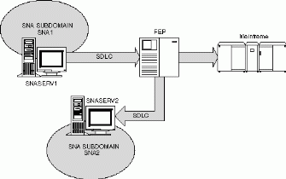
Figure 13.7: SNA Protocol Link Between Two Sites. In this example, SNASERV1 and SNASERV2 are connected to a FEP using the SDLC protocol. Since only SDLC lines exist between SNASERV1 and SNASERV2, it is difficult for an administrator at SNASERV1 to manage the subdomain that SNASERV2 is a part of (SNA2).
See full-sized image.
The solution to this dilemma is to use an SNA Server feature called SNA remote access service (SnaRas). SnaRas allows SNA Server administrators to manage remote SNA Server subdomains over an SNA WAN link.
In order to better understand this SNA Server capability, let's first understand how the standard Windows NT RAS access is typically used. Remote access service (RAS) is a feature of Windows NT that is typically used in non-SNA environments to provide remote users dial-up access to the corporate network over a regular phone line. For example, in Figure 13.8, the user RAY accesses the corporate network using a modem to dial up the Windows NT Server computer at the corporate site. All that's required for this to work is for the Windows NT computer at the corporate site to have the RAS service configured and a RAS client to be configured at RAY's computer. The protocols used in this RAS communication are client/server protocols such as TCP/IP, IPX/SPX, or NetBEUI. Once users have access to the RAS server, they can, if the RAS server security configuration allows it, get access to the rest of the network.
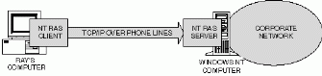
Figure 13.8: Standard RAS Access. In this example, the user RAY accesses the corporate network by using a modem to dial-up the Windows NT Server computer at the corporate site. The Windows NT computer at the corporate site has the NT RAS service configured and RAY's computer has the NT RAS client configured. The protocol used in this NT RAS communication is TCP/IP. Once users have access to the RAS server they can, if the RAS server security configuration allows it, get access to the rest of the network.
See full-sized image.
SnaRas uses Windows NT RAS for a very similar purpose. An SnaRas client can access the SnaRas server in order to gain access to that server and to the rest of network. The difference is that, instead of using regular phone lines to communicate between the SnaRas client and the SnaRas server, SnaRas uses an existing SNA WAN link as its underlying communication path. SnaRas uses APPC LU's to establish communications between an SNA Server at one site and another SNA Server at the remote site. SNA Servers can communicate using client/server protocols over this SnaRas connection, which allows an SNA Server administrator at one site to manage the SNA Server subdomain at the other site. In fact, once the SnaRas client can gain access to the remote client/server network through the SnaRas server, the SNA Server administrator can use the SNA Server manager to manage any SNA Server subdomains configured at the remote site.
Top of page

Installing and Configuring SnaRas
When configuring SnaRas, you must configure two SNA Servers, one at each site. The SnaRas software component of SNA Server must be installed on the SNA Server configured as the SnaRas server. The SnaRas software component must also be installed on the computer acting as the SnaRas client, which can be either an SNA Server or a Windows NT SNA Server client. To install the SnaRas component on the SNA Server, you must follow the steps described in Chapter 3, "Installing SNA Server." To install the SnaRas component on the SNA Server client, you must follow the steps described in Chapter 8, "Installing and Configuring SNA Server." Figure 13.9 illustrates a typical SnaRas environment.
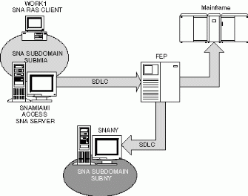
Figure 13.9: SnaRas Client in Miami Accesses SnaRas Server in New York. In this example, the SNA Server administrator at the Miami site would like to administer the SNA Server subdomain at the New York site (SUBNY), but the only link between the two sites uses SNA protocols only. In order to allow the SNA Server administrator to manage the SNA Server subdomain in New York SnaRas must be configured. In this case the Windows NT Workstation, WORK1 will be the SnaRas client, and the SNA Server SNANY will be the SnaRas server. It will use the link service, connection, and APPC LUs configured on the SNA Server, SNAMIAMI to access the SNA Server, SNANY at the remote site.
See full-sized image.
SnaRas can only be installed on a Windows NT computer.
The SNA Server administrator at the Miami site would like to administer the SNA Server subdomain at the New York site, but the sole link between the two sites uses only SNA protocols. To allow the SNA Server administrator to manage the SNA Server subdomain in New York, you must configure SnaRas. In this case, the Windows NT Workstation WORK1, will be the SnaRas client. It will use the link service, connection, and APPC LUs configured on the SNA Server SNAMIAMI to access the SNA Server, SNANY, at the remote site. In this typical scenario the components that need to be installed on each computer for SnaRas to work are as follows:
• | On the SNA Server client (WORK1)—You must install Windows NT RAS, as well as the SNA Server client software, along with the SnaRas software component.
• | On the SNA Server SNAMIAMI—You must install the SNA Server software.
• | On the SNA Server SNANY—You must install Windows NT RAS, as well as the SNA Server software, along with the SnaRas software component.
The SNA Server itself may also act as the SnaRas client. In such a case, the SnaRas feature must also be installed on the SNA Server, SNAMIAMI.
Consult the Windows NT documentation for information on the steps required for installing RAS.
Once the proper software is installed, you can configure SnaRas access. To simplify this configuration description, we refer to the SNA Server that provides access to the SnaRas server on behalf of the SnaRas client as the access SNA Server. In the example illustrated in Figure 13.9, the access SNA Server is SNAMIAMI. The SNA Server that is being accessed is known as the SnaRas server. In Figure 13.9, SNANY is the SnaRas server. The SnaRas client is the computer that communicates with the SnaRas server through the access SNA Server. In Figure 13.9, the WORK1 computer is the SnaRas client. In order to configure SnaRas you must configure the SnaRas server, the access SNA Server, and the SnaRas client.
To configure the SnaRas server, you must perform the following steps:
1. | Configure a link service—This configures the data-link layer protocol that this SNA Server will use to communicate with the access SNA Server. This is covered in detail in Chapter 4, "Configuring Link Services and Connections."
2. | Configure a connection—This connection establishes a pointer to the access SNA Server. The connection must have a Remote End of Peer and Allowed Directions must be set to Incoming Calls. This is covered in detail in Chapter 4, "Configuring Link Services and Connections."
3. | Configure a local APPC LU on the SNA Server—This local APPC LU will be paired with a remote APPC LU configured on the other SNA Server. The Network Name and LU Name of this APPC LU must match the Network Name and LU Name of the remote APPC LU configured on the access SNA Server. APPC LU configuration is covered in detail in Chap-ter 6, "Configuring SNA Server in a Peer-Oriented Environment."
4. | Configure a remote APPC LU on a Connection—SnaRas will use this APPC LU to communicate with the access SNA Server. The Network Name and LU Name of this APPC LU must match the Network Name and LU Name of the local APPC LU configured on the access SNA Server. When configuring this APPC LU, you must select the connection configured to reach the access SNA Server. APPC LU configuration is covered in detail in Chapter 6, "Configuring SNA Server in a Peer-Oriented Environment."
5. | Configure an SnaRas port—An SnaRas port is used by the SnaRas client to access the SnaRas server. The steps required to configure this are outlined below.
6. | Grant dial-in permissions to users—You must grant dial-in permissions to any users or groups wishing to access the SnaRas server. The steps required to configure this are outlined shortly.
This steps required for configuring link services, connections, and APPC LUs are described in earlier chapters; below is a description of the steps required to configure an SnaRas port and configure dial-in permissions.
To configure a RAS port, you must perform the following steps:
1. | Access the Network icon in the Control Panel.
2. | In the Network window on the Services tab, select Remote Access Service, and then click theProperties button. The Remote Access Setup window appears, as shown in Figure 13.10.
3. | Click the Add button, select any of the available RAS-capable devices, such as RasSna1—SnaRas, and then click OK. This returns you to the Remote Access Service window.
4. | Select the SnaRas port you've just added, and then click Configure.
5. | In the Configure Port Usage window, shown in Figure 13.11, verify that the SnaRas port is configured to Receive Calls Only, and then click OK.
6. | By clicking the network button, you can configure the SnaRas port to use any of the three supported RAS protocols, TCP/IP, IPX/SPX, or NetBEUI. It doesn't matter which you use as long as it matches the protocol in use by the SnaRas client.  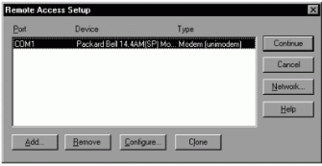  Figure 13.10: Remote Access Setup Window.  See full-sized image.  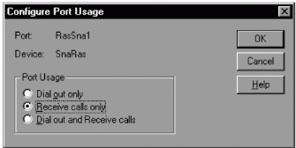  Figure 13.11: Configure Port Usage Window.  See full-sized image.
You can configure dial-in permission by performing the following steps:
1. | Open the Windows NT User Manager by selecting its shortcut on the Start menu, Programs, Administrative Tools group. The User Manager Window appears.
2. | Select the user to whom you wish to grant dial-in permission in User Manager, and then configure its properties.
3. | In the User Properties window, click the Dial-in button. The Dial-in Information window appears, as shown in Figure 13.12.
4. | Click the checkbox labeled Grant Dial-in permission to user.  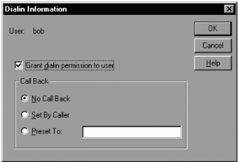  Figure 13.12: Dial-In Information Window.  See full-sized image.
To configure the access SNA Server, you must perform the following steps:
1. | Configure a link service—This configures the data-link-layer protocol that this SNA Server will use to access the SnaRas server. This is covered in detail in Chapter 4, "Configuring Link Services and Connections."
2. | Configure a connection—This connection establishes a pointer to the SnaRas server. The connection must have a Remote End of Peer and Allowed Directions must be set to Outgoing Calls. This is covered in detail in Chapter 4, "Configuring Link Services and Connections."
3. | Configure a local APPC LU on the SNA Server—The LU alias name of this LU must be SnaRasLU, because this is the LU alias that the SnaRas TP is programmed to use as its local APPC LU. The Network Name and LU Name of this APPC LU must match the Network Name and LU Name of the remote APPC LU configured on the SnaRas server. The LU name can be different than the LU alias. APPC LU configuration as well as LU aliases and LU names are covered in detail in Chapter 6, "Configuring SNA Server in a Peer-Oriented Environment."
4. | Configure a remote APPC LU on a Connection—SnaRas uses this APPC LU to access the SnaRas server. The Network Name and LU Name of _this APPC LU must match the Network Name and LU Name of the local APPC LU configured on the SnaRas server. When configuring this APPC LU, you must select the connection configured to access the SnaRas client. APPC LU configuration, as well as LU aliases and LU names, are covered in detail in Chapter 6, "Configuring SNA Server in a Peer-Oriented Environment."
To configure the SnaRas client, perform the following steps:
1. | Configure an SnaRas port that will be used to dial the SnaRas server— The SnaRas port is configured just as it is done at the SnaRas server, except that the port usage should be configured as Dial Out Only.
2. | Configure a phonebook entry—The phonebook entry is typically used with RAS as a database of phone numbers to dial. With SnaRas, you must configure a phonebook entry as well to access the SnaRas server. With SnaRas, however, you don't really configure a phone number, but instead you specify the name of the remote APPC LU to be used to access the SnaRas server. The steps required to configure a phonebook entry are detailed below.
You can configure the phonebook entry by performing the following steps:
1. | From the Start menu, select Programs, Accessories, and Dial-Up Networking. The Dial-Up Networking window appears, as shown in Figure 13.13
2. | In the Dial-Up Networking window, click the New button to configure a new phonebook entry. The New Phonebook Entry window appears, as shown in Figure 13.14.  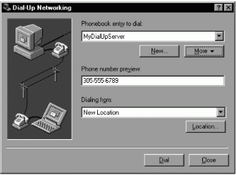  Figure 13.13: Dial-Up Networking Window.  See full-sized image.  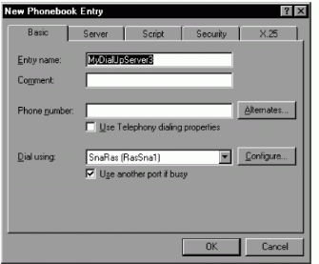  Figure 13.14: New Phone Book Entry Window, Basic Tab.  See full-sized image.  If the New Phonebook Entry Wizard window appears, select the check box titled I know all about phonebook entries and would rather edit the properties directly so that you can access the manual configuration tabs.
3. | Select the SnaRas(RasSnaX) port from the Dial using pull-down box (where X is the specific SnaRas port number you wish to use).
4. | In the Phone number field of the Basic tab, enter the name of the remote APPC LU to use with this entry, followed by the mode to use, such as SnaRas #INTER.
After completing the necessary configurations, perform the following steps to use SnaRas.
1. | Start the SNA Service on the SnaRas server and the access server.
2. | If the service is not already started, start the RAS service on both the SnaRas client and the SnaRas server. This service should start automatically whenever Windows NT is started.
3. | Dial the SnaRas server by selecting the phonebook entry you just configured on the Phonebook entry to dial property in the Dial-Up Networking window, and then click Dial, as shown in Figure 13.15.  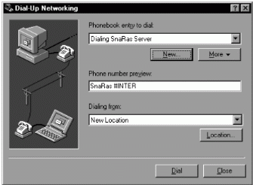  Figure 13.15: Dial-Up Networking Window.  See full-sized image.

Configuring and Managing SNA Server Resources Using Snacfg
Most of the SNA Server configuration steps we have described so far are performed using the SNA Server Manager configuration utility. SNA Server also includes a utility called Snacfg, that allows you to configure almost anything with the SNA Server Manager, by using the command-line instead of the graphical interface. At first it seems as though there is no reason why anyone would want to use Snacfg when they could use a much more user friendly tool like the SNA Server manager. This is often true. In fact, it is recommended that you use the SNA Server manager for most of your configurations. However, there are some circumstances under which the Snacfg command-line utility can be useful, as in any of the following cases:
• | You can use Snacfg when you wish to make a quick configuration without accessing the SNA Server manager. For example, it may be that you are accessing the SNA Server from a workstation that does not have the SNA Server manager installed. Instead of having to install the SNA Server manager, you can use the Snacfg utility to perform the required tasks.
• | Snacfg allows you to group a set of configuration commands. This group of commands can be saved in a configuration file called a command file so that the grouped commands can be executed easily at any point in time.
• | You could use the Snacfg utility to configure an offline configuration file if you didn't have access to SNA Server manager. An offline configuration file is an SNA Server subdomain configuration file that is not currently being used in a production environment.
Prior to running the Snacfg program for the first time, you must run the SNA Server manager program at least once. This initializes operating aspects of the SNA Server configuration that cannot be done with the Snacfg utility.
The Snacfg utility is installed with every copy of SNA Server. It is located in the \[Snaroot]\System directory.
Top of page

Snacfg Syntax
By providing the necessary configuration parameters, you can use the Snacfg utility to accomplish such tasks as configuring new connections or new LUs.
The syntax required for executing an Snacfg command is as follows:
Snacfg #configpath command options
The #configpath parameter allows you to specify the location of the configuration file. For example, if you're configuring a COM.CFG configuration file located in the C:\SNA directory, you would specify the following,
Snacfg #C:\sna\com.cfg command options
If you do not specify the path for the configuration file, the Snacfg _utility will automatically search the default COM.CFG location, which is \[Snaroot]\System\Config. Therefore, if you run the Snacfg utility on the SNA Server and you wish to configure the SNA Server's online com.cfg, you do not need to specify the location of the com.cfg, because it will automatically find it in this default location. In such a case, you can bypass the need to specify the location of the com.cfg and simply use the following command syntax,
Snacfg command options
After specifying the location of the configuration file, you need to specify the command to execute. To obtain a list of all commands available with Snacfg, you can type the word Snacfg at the command prompt, as shown in Figure 13.16.
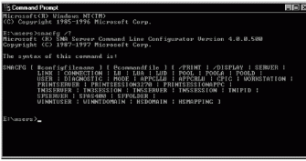
Figure 13.16: Snacfg List of Commands.
See full-sized image.
Snacfg commands are used to configure resources in the configuration file, such as connections, LUs, print sessions, etc. Each command has a syntax that is required for configuration and a list of options that can be specified when using the command. If you want to see the syntax for a given command and the options available with it, you can type Snacfg at the command line, followed by the command name. For example, if you type Snacfg lu, the following list of syntax and options for the LU command will be displayed,
The Syntax of this command is:
Snacfg LU /LIST
Snacfg LU LUNAME
Snacfg LU LUNAME /PRINT
Snacfg LU LUNAME /ADD [OPTIONS]
Snacfg LU LUNAME [OPTIONS]
Snacfg LU LUNAME /DELETE
Available options are:
/CONNECTION:TEXT
/LUNUMBER:VALUE
/POOL:TEXT
/COMMENT:"COMMENT"
/ALLOWMODEOVERRIDE:{Yes | No}
/LUTYPE:{Display | Printer}
/DISPLAYMODEL:{Mod2|Mod3|Mod4|Mod5|2|3|4|5}
/ASSOCIATE:text
/UNASSOCIATE:text
You can see from these options that they are essentially equivalent to the LU property values that you would typically specify within the SNA Server Manager. For example, you can add an LU by using the /ADD command or delete an LU by using the /DELETE command. One of the most powerful reasons to use the Snacfg utility is the ability to use a command file.
Top of page

Using a Command File with Snacfg
SNA Server configuration involves many tasks. For example, in Chapter 5, "Configuring SNA Server in a Hierarchical Environment," you learned that, if you want to configure 3270 terminal access, you need to configure link services, connections, LUs, users, and so on. Using the Snacfg utility to perform these configurations does not mean you have to type the proper commands at the command line over and over again. You can, instead, group the commands that you want to execute into a command file, which will then be invoked by Snacfg using the following syntax:
Snacfg #configpath @commandpath options
To maintain consistency, an Snacfg command file is typically saved using the .EXT extension. For example, you may create a command file called LUS.EXT, that creates two LUs as specified here:
LU TEST /ADD /CONNECTION:CONN1 /LUNUMBER:3
LU TEST1 /ADD /CONNECTION:CONN1 /LUNUMBER:4
After creating the command file and saving the file in the c:\SNA directory, you can execute its commands by typing the following at the command line:
Snacfg c:\SNA\LUS.EXT /V
This opens the configuration file and executes the commands within the command file, which create the two LUs, TEST and TEST1, and assigns them to the connection CONN1 with LU numbers 3 and 4, respectively, and then closes the configuration file. The command, as it is specified here, assumes that the configuration file is stored in the default path and that the command file is stored in the C:\SNA directory. The /V option causes all informational messages to be displayed when the command file runs. A command file can be used to configure thousands of SNA Server resources at a time and can be reused at any point by simply invoking it with the Snacfg utility.
Top of page

Study Break

Configuring from the Configured
One interesting capability of the Snacfg utility is its ability to create a command file from an existing configuration. For example, if one SNA Server in your organization is configured with pretty much the same resources that you're going to need to configure another SNA Server, you can create a command file from the first SNA Server's configuration and execute that command file on the second SNA Server in order to configure that SNA Server with the same resources as the first. To accomplish this, perform the following steps:
1. | At the SNA Server computer which is already configured, execute the following command:  Snacfg /print >comfile.ext  Assuming that the com.cfg is in the default directory, this command will create a command file called comfile.ext which contains all of the commands necessary to recreate this SNA Server's current configuration.
2. | You may need to modify some aspects of the command file prior to using it for another configuration.
3. | Copy the file comfile.ext to the second SNA Server computer's root directory and execute the following command:  Snacfg @c:\comfile.ext /v  Assuming that the com.cfg is in the default directory, this command will configure this SNA Server exactly as the first is configured.
If the com.cfg is not located in the default directory in either of the two SNA Servers, you simply need to specify the correct location of the file when executing the Snacfg command.
Top of page

Tracking and Improving SNA Server Performance
One of the most important aspects of SNA Server maintenance is to verify that SNA Server performance is satisfactory. If performance issues do exist, we have to be able to improve SNA Server performance by addressing the bottlenecks. This section describes some of the tools that can be used to measure SNA Server performance and some steps that can be taken to improve it.

Using Performance Monitor
One of the best ways of monitoring SNA Server performance is to use the Windows NT performance monitor. Performance monitor can be used to track SNA Server activity, as well as to measure the performance of the Windows NT computer itself. Performance monitor works by allowing you to select certain aspects or elements of the computer that you would like to measure. For example, you may want to measure how many bytes per second of data a particular network card installed in the computer is processing. To use performance monitor to measure this or any other performance aspect of your computer, you can perform the following steps:
1. | Access the performance monitor tool by clicking the Windows NT Start menu, pointing to Programs, pointing to Administration Tools, and then selecting Performance Monitor. The Performance Monitor window appears, as shown in Figure 13.17.  On the Edit menu, select Add to Chart. The Add to Chart window appears, as shown in Figure 13.18. You must specify the following properties in order to organize the data to be measured:
  • | Object—These are different elements of a computer that can be measured. An object may be hardware or software. An example of an object is the processor or the paging file.
  • | Counter—This defines what about the object we want to measure. For example, we may want to measure the %Processor Time for the processor or the %Usage for the paging file.
  • | Instance—Some counters may refer to multiple instances. For example, there may be multiple paging files configured on a given computer. The Instance property allows you to choose which one to measure.
2. | Once you configure the things to measure, click Done to return to the Performance Monitor window. The window now displays the information for the counter you just added to the chart.  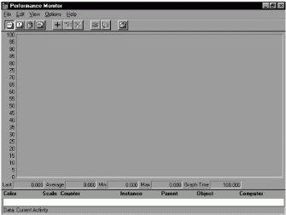  Figure 13.17: Performance Monitor Window.  See full-sized image.  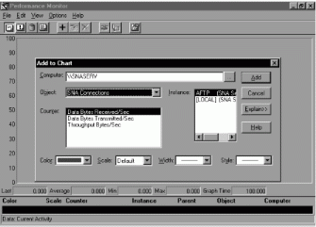  Figure 13.18: Add to Chart Window.  See full-sized image.
When SNA Server is installed, it adds its own sets of objects, counters, and instances to the performance monitor. SNA Server objects and counters, like all objects and counters, are depicted in the form object:counter. For example, the Windows NT counter used to measure %Processor Time is listed as Processor:%Processor Time, Processor is the object and %Processor Time is the counter. The following are some of the most important objects and counters to measure when assessing the performance of SNA Server.
The next two groups of counters are not specific to SNA Server, but instead are used to assess the performance of the computer on which SNA Server is installed, as well as the performance of the SNA Server.
• | Memory:Pages/Sec—Windows NT computers are capable of using hard disk space as temporary storage for memory. Data is written to and from memory as required. This counter measures how many times per second the computer writes or reads from the hard drive for paging purposes. Excessive paging can significantly reduce the performance of SNA Server because it takes much longer to access data stored on a hard drive than to access data in memory. It's difficult to determine exactly how much is excessive, but one good test is to check the System:%Total Processor Time. If this counter is decreasing as Memory:Pages/Sec increases, it indicates that the processor is being forced to wait for data being accessed on the hard drive before it can do any processing. If there is excessive paging, you can either increase the amount of memory in the computer or transfer some of the access load to another computer.
• | System:%Total Processor Time—This counter can be used to monitor how busy the processor is keeping. It measures the fraction of total processor time that the processor spends doing useful work. It is not uncommon to see values of 60 to 80 percent maintained during heavy loads. However, this value should never stay at 100 percent for any sustained period of time. If the computer is consistently staying at 100 percent, you probably need to either upgrade the processors or transfer some of the load from the computer.
Table 13.2 provides a list of all of the objects and counters available with SNA Server. Performance monitor can also be used to record RTM responses, which we will describe in more detail in the next section. There are many more Windows NT objects and counters that exist that can be used to further study the computer's performance, as well as many more features that Perfmon, which is the name by which many engineers know this tool, provides to measure system performance. The Windows NT documentation provides information on Perfmon and the Windows NT objects and counters.
Measurement of frames per second provides a better indicator of server load than bytes per second, because server overhead (for interrupt handling and message processing) increases per frame, not per byte. That is, a large frame with many bytes requires about the same overhead as a small frame with fewer bytes.
Table 13.2 SNA Server Performance Monitor Objects and Counters
Object | Counter | Description
SNA Connections | Data Bytes Received/Sec | This is used to measure the number of bytes/sec received on a specific connection.
 | Data Bytes Transmitted/Sec | This is used to measure the number of bytes/sec transmitted on a specific connection.
 | Throughput Bytes/Sec | This is used to measure the total number of bytes flowing in and out of this connection.
SNA Logical Unit Sessions | Data Bytes Received per Sec | This is used to measure the number of bytes/sec received on a specific LU.
 | Data Bytes Transmitted/Sec | This is used to measure the number of bytes/sec transmitted on a specific connection.
 | Throughput Bytes/Sec | This is used to measure the total number of bytes flowing in and out of the LU.
SNA Adapter adaptername | Adapter Failures | This is used to measure the number of times since startup that the adapter has had an error.
 | Connection Failures | This is used to measure the number of times since startup that the adapter has had a connection error.
 | Data Bytes Received/Sec | This is used to measure the number of bytes/sec received on a specific adapter.
 | Data Bytes Transmitted/Sec | This is used to measure the number of bytes/sec transmitted on a specific adapter.
 | Frames Received/Sec | This is used to measure the number of frames/sec received on a specific LU.
 | Frames Transmitted/Sec | This is used to measure the number of frames/sec transmitted on a specific connection.
 | Successful Connects | This is used to measure the number of times since startup that the adapter has established a successful connection.
 | Throughput Bytes/Sec | This is used to measure the total number of bytes flowing in and out of the adapter.
 | Throughput Frames/Sec | This is used to measure the total number of frames flowing in and out of the adapter.
The most basic unit of measurement used for network data transmission is a frame. Data bytes are packaged in frames in order to be transmitted on the network. One frame may carry many bytes of data while another may carry fewer bytes. A computer typically handles transmitted data in frames. Its resources, such as those dedicated for interrupt handling and message processing, must manage each frame. The computer's performance is typically more affected by the number of frames it must process than the number of bytes, regardless of the number of bytes each frame carries. For this reason, it may be more useful in judging SNA Server performance to measure the frame throughput rather than the byte throughput.
It is important to maintain a correlation between the SNA Server load as viewed on performance monitor and the actual load that can be seen in SNA Server manager. It may be that the performance monitor shows a very low value for SNA Connections: Throughput Bytes/Sec, but this may just mean that there are no users logged on to the SNA Server.
Many of SNA Server's objects and instances will not appear on the performance monitor Add to Chart window unless the object or instance you wish to measure is active.
Optimizing SNA Server Connection Performance
In Chapter 4, "Configuring Link Services and Connections," we covered the steps required to configure an SNA Server connection. You might remember that each connection includes an advanced tab in its connection properties window, which is typically named the same as the type of connection being configured. Most of the properties configured on that tab can be used to enforce proper flow control and efficient performance. Each connection type has a different set of properties that need to be configured. The following advanced properties are common to most connection types:
• | Basic transmission unit (BTU) length—This specifies the number of bytes that can be transmitted in a frame.
• | Pacing—This specifies the number of frames that can be sent or received at a time.
• | Request/response unit—This specifies how much of the frame can be used for sending useful data, instead of control data.
Top of page

Configuring the Basic Transmission Unit (BTU) Length
Data transmitted between devices at the data-link layer is packaged in data frames. These frames can handle varying amounts of data, depending on the physical medium being used. The Max BTU length property specifies the maximum number of bytes that can be transported in a single data link frame. Table 13.3 depicts the typical values supported for some of the SNA Server connection types.
Table 13.3 BTU Lengths Supported by each Connection Type
Connection type | Limit (in bytes)
802.2 DLC over 16 Mbits Token Ring | 16393
802.2 DLC over 4 Mbits Token Ring | 4195
802.2 DLC over Ethernet | 1493
Channel | 65,536
The maximum BTU length must be supported by every component used in the connection. When establishing a connection to the host, the following factors must be considered when configuring the Max BTU length at the SNA Server:
• | Network adapter—Different network adapters may support different maximum BTU lengths. You must verify that the BTU length to be configured is supported by the adapter.
• | Data link architecture—As you can see in Table 13.3, the maximum BTU lengths supported varies depending on the data link architecture in use. You must verify that the BTU length to be configured is supported by the data link architecture.
• | Host configuration—Just as you configure a Max BTU Length on the SNA Server, so too, will the host administrator define a maximum BTU value on the host. On a mainframe, the BTU length is specified in the MAXDATA property on the VTAM PU definition. On the AS/400, the BTU length is specified in the MAXFRAME property in the controller description.
After determining the BTU length supported, you can configure the Max BTU Length on SNA Server by configuring the advanced tab of the connection properties, as shown in Figure 3.19.
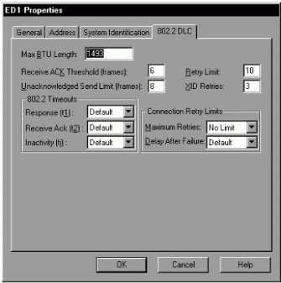
Figure 13.19: Connection Properties Window, 802.2 DLC Tab.
See full-sized image.
Typically, SNA Server will use the smallest BTU length supported by any of the factors considered. For example, even if you configure a BTU length of 4195 on SNA Server, if the Ethernet architecture only supports 1493, SNA Server will be forced to use 1493 as its BTU length. Likewise, if there's a mismatch between the value configured on SNA Server and the value configured on the host, the two will typically negotiate to the lowest value. This negotiation can always take place when the connection is configured to use XID format 3. If the connection uses XID format 0, however, there may be problems in establishing a connection if the BTU length values don't match. For this reason, when using XID format 0, you should ensure that the BTU lengths configured on the host and on the SNA Server match. XIDs are defined in Chapter 4, "Configuring Link Services and Connections."
Top of page

Configuring the Pacing Values
Pacing refers to how much data can enter or leave a device at given intervals. Like runners who might pace themselves for a long run, an SNA device must set a limit on how much data it can process in a given interval. Typically, pacing parameters are concerned with receiving an acknowledgment for a specified amount of data sent. For example, SNA Server might be configured to send 7 frames of data to the host before it expects an acknowledgment from the host confirming that it has received the 7 frames sent. In this case, the 7 frames are known collectively as the pacing window. Many different types of pacing windows can be established at all layers of data communications.
Pacing windows can influence SNA Server performance. If pacing windows are too low, the network bandwidth may get cluttered with many acknowledgment frames instead of data frames. If the pacing window is too high, it may create the need for a greater amount of retransmissions, which would also affect the use of bandwidth. The type of application for which the connection is being used determines the proper pacing window. Let's look at some of the most important pacing configurations to consider when configuring SNA Server.
When configuring APPC communications, the APPC mode defines the pacing windows for the APPC LU pairs. You can configure the following properties on the Characteristics tab of the APPC mode properties, as shown in Figure 13.20:
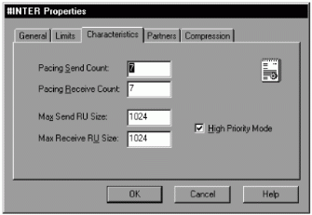
Figure 13.20: APPC Mode Properties, Characteristics Tab.
See full-sized image.
• | Pacing send count—This value specifies the number of frames that the local LU can send without receiving a response from the partner LU. The values can be from 0 to 63. The default is 4. If you specify 0, the local LU can send an unlimited number of frames without requiring a response. These values are negotiated between the local LU and the partner LU during session establishment.
• | Pacing receive count—This value specifies the number of frames that the local LU can receive without sending a response to the partner LU. The values can be from 0 to 63. The default is 4. If you specify 0, the local LU can receive an unlimited number of frames without sending a response. These values are negotiated between the local LU and the partner LU during session establishment.
Another important pacing property that can be configured is on DLC 802.2 connections.
The following is configured on the 802.2 DLC tab of the DLC 802.2 connection properties window. (See Figure 3.19.)
• | Receive ACK threshold (frames)—This specifies the maximum number of frames that the SNA Server can receive from the remote system before sending an acknowledgment.
• | Unacknowledged send limit (frames)—This specifies the maximum number of frames that the SNA Server can send without receiving an acknowledgment from the remote system. This is often known as the "send window size."
Top of page

Configuring the Request/Response Unit size
One other aspect to consider when fine tuning data communication performance with SNA Server is determining the RU size. A request/response unit (RU) contains the data that needs to be transmitted to and from LUs. This may be end user data or it may be control data used for managing the session. When configuring APPC communications, the APPC mode defines the RU sizes for the APPC LU pairs. You can configure the following properties on the Characteristics tab of the APPC mode properties:
• | Max Send RU Size—You must specify the maximum RU size that this mode allows to be sent. The range is from 256 through 16384.
• | Max Receive RU Size—Specify the maximum RU size which this mode can receive. The range is from 256 through 16384.

Optimizing SNA Server Performance _with Multinode Support
Another way to enhance SNA Server performance is to spread the SNA Server traffic across multiple SNA services, which are also known as nodes. SNA Server allows you to insert up to 3 SNA Server services in SNA Server manager, for a total of four SNA Server services. This is similar to running four different copies of SNA Server on a single computer. You can enhance the performance of SNA Server by spreading the configured connections and LUs across these multiple SNA Server services. This SNA Server feature is known as multinode support. For the most part, a multinode SNA Server behaves just like any SNA Server. The exception is that each SNA Server service configured has equal access to thread processing. So if, for example, 100 connections are configured on a single SNA Server service, each connection is dependent on that single service's thread priority. If, however, those 100 connections are spread across 4 SNA Server services, then only 25 connections share a service's thread processing.
To configure an SNA Service:
1. | Select SNA Service from the SNA Server manager Insert menu. A confirmation prompt appears asking if you're sure you want to create the service.
2. | Click Yes. The new SNA Server appears on the left pane of the SNA Server manager. SNA service names will be SNA Service 02, SNA Service 03, and SNA Service 04 as you create the second, third, and fourth service, respectively, as shown in Figure 13.21.  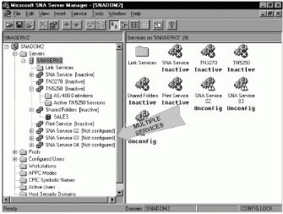  Figure 13.21: Mutinode SNA Server Computer.  See full-sized image.
Mutinode support can also be used to increase the number of resources that SNA Server supports. For example, a single SNA Server supports a maximum of 15,000 sessions, while adding a second SNA Server can increase the session maximum to 30,000.
Configuring Response Time Monitors
When working with 3270 sessions, you can monitor the time required for the host to respond to 3270 client requests. This data can be collected using a response time monitor (RTM). RTM data can be sent to the host to be analyzed by host administrators; it can also be viewed at the user's 3270 display session, as well as by using the Windows NT performance monitor. Most 3270 emulators can collect and display RTM data, but some, such as TN3270 emulators, don't. The emulator must support RTMs in order for RTM data to be collected, since the response time is measured from the host all the way to the emulator.
Every time a 3270 user selects a key that sends data to the host, such as the ENTER key, the timer starts. The data is processed by the host and then returned to the user's 3270 session, where the RTM timer stops. The timer value collected is then compared to four different boundary values. For example, one value may be 0-.5 seconds. If the RTM timer returns a value of 3 seconds, then the 0-.5 seconds boundary's counter will be increased by one. This way SNA Server and host administrators can determine how long most sessions are taking. In a properly functioning environment, RTM counters should remain relatively low. Low is often considered to be host response time of less then two seconds. If the higher boundaries, such as 2 to 5 seconds, have consistently high counters, it may indicate a performance problem on the network.
To configure RTMs, access the Response Time Monitoring (RTM) tab of the subdomain properties window, as shown in Figure 13.22, and configure the properties defined in Table 13.4.
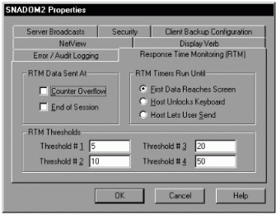
Figure 13.22: Subdomain Properties, Response Time Monitor Tab.
See full-sized image.
RTM data collected by the SNA Server can be forwarded to the host over the NetView connection. Earlier in this chapter, we described how to configure a NetView connection.
RTM values configured on SNA Server govern all the SNA Servers in a subdomain. However, any RTM configurations made at the host will override RTM settings for the SNA Server.
Table 13.4 RTM Properties
Property | Definition
RTM Data Sent At | This allows you to configure when the RTM counters are forwarded to the host. You may choose to send the RTM counters at both the close of a session and at counter overflow. RTM counters are reset after the RTM data is sent.
Counter Overflow | This sends the RTM data when the number of RTM timers that have been logged to a boundary exceeds the maximum size of the available counter. For example, if the 2 to 5 second boundary is exceeding its counter maximum, the host administrator will want to know immediately since this may indicate a problem with the system.
End of Session | This will forward RTM data each time an LU session is ended.
First Data Reaches Screen | Selecting this option stops the timer when the data returning from the host reaches the user's terminal session screen.
Host Unlocks Keyboard | Selecting this option stops the timer when the host unlocks the user's keyboard.
Host Lets User Send | Selecting this option stops the timer when the host allows the local computer to send data.
RTM Thresholds | As RTM timers are collected, their values are compared against different boundaries to determine which counter to increment. These boundaries are established by configuring the boundary thresholds. The values are in tenths of a second. The default values are 5, 10, 20, and 50.
Configuring Data Compression
Today's AS/400 and mainframe operating systems have the ability to compress the data transferred between SNA devices at the LU level. SNA Server can be configured to take advantage of this capability. Data compression increases data throughput, which can lead to enhanced SNA Server performance. Compression reduces the amount of data sent over the network, but it does consume more CPU cycles, which are required to compress and decompress the data.
SNA Server provides the following types of data compression:
• | Display LU level compression between the host and the SNA Server—To configure data compression for 3270 LUs, you configure the properties of the LU on the General tab, and then click the Use Compression checkbox, as shown in Figure 13.23.  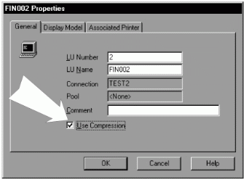  Figure 13.23: 3270 LU Properties Window, General Tab.  See full-sized image.  APPC LU level compression between the host and the SNA Server—To configure data compression for APPC LUs, you configure the properties of the mode and, on the Compression tab, shown in Figure 13.24, configure the following properties:  Maximum Send Compression—SNA Server allows you to use compression types Run Length Encoding (RLE) and LZ9 with APPC LUs. LZ9 is better compression then RLE, but it consumes more CPU cycles. This property allows you to specify which compression type to use when sending data. The options are none, RLE, and LZ9.  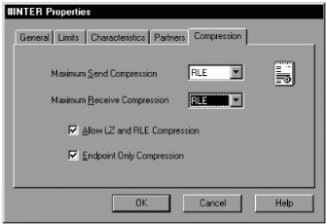  Figure 13: Mode Properties, Compression Tab.  See full-sized image.
• | Maximum Receive Compression— This property allows you to specify which compression type to use when receiving data. The options are none, RLE, and LZ9.
• | Allow LZ and RLE compression—When using LZ9 compression, the data can sometimes be compressed using RLE before it is compressed using LZ. Selecting this property allows RLE to be used for compression prior to compressing again using LZ9.
• | Endpoint Only Compression—You may choose not to use compression on SNA Server, but the intermediate nodes which SNA Server uses to access the partner TP may be configured to use compression themselves. Selecting this property forces compression to take place only if configured on the endpoints where the local and partner LUs are actually configured.
• | Client/server protocol compression between two SNA Servers—You can also configure compression between two SNA Servers communicating through the distributed link service by clicking the Compression Used checkbox on the distributed link service properties window.
There are no application changes required to use data compression. The upper-layer applications are simply not aware that the data is being compressed at the LU level.
Top of page

Study Break

Using Performance Monitor Without Access to a Host
Performance monitor can be used even if you are not actually accessing a host computer. To do so, all you need to do is follow the instructions provided in previous chapters for configuring any type of SNA Server demo access. In other words, configuring SNA Server when no host is available, such as configuring 3270 access or 5250 access using the demo SDLC link service. After properly configuring demo access, you can select any of the SNA Server objects and counters listed in this chapter in order to view SNA Server performance. This, of course, does not provide you with accurate performance readings since you're not actually accessing a host, but it does give you an idea of how Perfmon works.
Troubleshooting SNA Server Communications
Yes, problems do occur. For the most part, those problems relate to how one device deals with another within the SNA Server environment. Mostly the type of communications to troubleshoot in an SNA Server environment are between SNA Server and the host, between SNA Servers themselves, and between SNA Server clients and SNA Servers. This section describes some of the problems that can occur with these communications and how best to troubleshoot, or better yet, avoid those problems.
If an error does occur, there are a few steps that can be taken to resolve those errors, such as checking the SNA Server online help or checking the events logged in the event viewer. If the error continues and you don't seem to be able to find the source of the problem, you can resort to tracing SNA communications.
Troubleshooting SNA Server-to-Host Communications
The first step in configuring SNA Server host access is to configure the physical and data-link level paths to the host. This means that the SNA network connecting the SNA Server and the host must be in place and that the proper network adapters must be configured on both the host and the SNA Server. If the SNA Server will be accessing the host through another device, such as an FEP or cluster controller, the network adapters on those devices must be properly configured, as well.
As an SNA Server administrator, it may or may not be your responsibility to ensure that the SNA network is in place or that the host adapters are configured, but you certainly won't be able to establish communications unless they are. Although we typically depend on the SNA host administrators to handle most of the configurations on the host, there are a couple of things we can check to improve our chances for successful SNA Server-to-host communications:
• | Assure that a proper data network exists between the SNA Server and the host.
• | Assure that the SNA adapter installed on the SNA Server does not have any resource conflicts with any other device in use by the SNA Server computer. Resource conflicts, such as duplicate IRQs or memory addresses, will cause the adapter driver to fail on startup, which would prevent the SNA Server link service from starting. If you suspect resource conflicts, check the event viewer for any logged events that may show where the conflict is. Resource conflict problems normally appear in the System log. Verify that the adapter is working properly by using the adapter's configuration utility.
• | The host must have a properly configured port definition for the adapter port and the adapter must be functioning properly. Consult with the host administrator to verify the adapter status.
These physical level and data-link level problems can sometimes be difficult to track. This is because when you attempt to start an SNA Server connection and it fails, it is common to troubleshoot the connection itself, when in reality the problem may lie with a faulty adapter or malfunctioning network.
Troubleshooting Connection and LU Problems
After verifying that the network is in place and functioning and that the network adapters at both ends are functioning, you need to verify that the SNA Server connections and LUs are properly configured. As with physical and data link communications, properly configured connections and LUs involve work on the part of the host administrator as well as the SNA Server administrator. Values configured on both the host and the SNA Server must match in order for communications to be established. Complicating things a bit is the fact that many of these values have different names on the host than they do on the SNA Server. Many of these parameter mappings are described earlier in this book in Chapter 4, "Configuring Link Services and Connections," Chapter 5, "Configuring SNA Server in a Hierarchical Environment," and Chapter 6, "Configuring SNA Server in a Peer-Oriented Environment." The SNA Server online help can also be very useful when determining the proper parameter mappings. For example, Figure 13.25 displays a typical SNA Server online help window that defines some of the different VTAM PU parameter mappings.
As we learned in Chapter 4, "Configuring Link Services and Connections," when connecting to a mainframe, the mainframe administrator must first configure a VTAM PU definition. This is what defines the SNA Server node on the host. The SNA Server configuration must correspond to the configured PU definition. Any mismatched values between the PU definition and the SNA Server connection can cause the connection to fail.
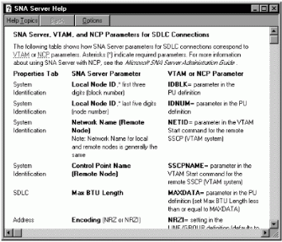
Figure 13.25: SNA Server Online Help.
See full-sized image.
When connecting to an AS/400, the SNA Server connection cor-_responds to an AS/400 controller description. The AS/400 administrator must have previously defined the controller description or the AS/400 AUTOCRTCTL feature must be set to yes.
After the proper PU definitions or controller descriptions are configured on the hosts, the proper LU definitions must be configured. As with SNA Server connections, the LU property values must match the property values defined on the host. Mismatches in these definitions can also cause communication problems.
Some of the events that may be logged to the event viewer when SNA Servers fail to connect to the host are as follows:
• | Event 230—This error usually occurs with DLC 802.2 connections. DLC 802.2 connections send an initial TEST frame to the host in order to establish the connection. Event 230 indicates that the remote system is not replying to TEST frames. In other words, this indicates that the SNA Server is not able to access the host. This can be due to any of the issues we've discussed so far, such as a faulty network, a faulty network adapter, or connection property mismatches. The key property values to check on the SNA Server connection are the Remote Network Address, the Network Name and Control Point Name (both local and remote), and the SAP Address values. Figure 13.26 illustrates a typical event 230 error in event viewer.  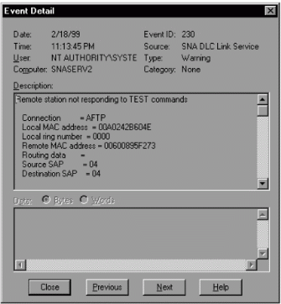  Figure 13.26: Even 230 Error in Event Viewer.  See full-sized image.  Event 23, Event 56—These also indicate connection failures. Each can be used to describe a failure in a wide range of the communication areas, from a hardware error to a link service error or connection mismatch. When these events are logged, a series of subcodes will appear, further detailing the possible causes of the error.
Troubleshooting SNA Server-to-SNA Server Communications
SNA Servers that participate in a common subdomain must communicate with each other in order to maintain an updated list of available resources in the subdomain. When SNA Server is first installed, it tries to find the primary configuration server (PCS) over mailslot or datagram broadcast messages. If the SNA Server cannot find the PCS through a broadcast, it will prompt you for the name of the subdomain's PCS in order to make a directed call to that server. Once the SNA Server locates the primary it is able to collect resource information by using its SnaBase service.
SNA Servers can communicate with each other over one of four client/server protocols, TCP/IP, IPX/SPX, Microsoft networking (Named Pipes), or Banyan Vines. All SNA Servers in a subdomain should be configured to use at least one common client/server protocol for SNA Server-to-SNA Server broadcasts. If all SNA Servers in a subdomain are configured to use TCP/IP for SNA Server-to-SNA Server communications, for example, and you install an SNA Server that uses IPX/SPX, that server will not be able to communicate with the other SNA Servers in the subdomain.
By default, SNA Server computers are configured to broadcast over all four protocols. If all four protocols are configured on the Windows NT domain, the SNA Server will broadcast messages using all four of them, which may cause unnecessary traffic on the network. It is recommended that you decide on the ideal protocol to use for server-to-server communications and configure each of your servers to communicate using only that protocol.
To configure the protocol to use for server-to-server communications, you must configure the properties of the subdomain, and on the Server Broadcasts tab (shown in Figure 13.27), select the checkbox for the proper protocol to use. Clear the checkbox for the protocols you don't want the SNA Server to broadcast over. It is recommended that you do not choose Microsoft Networking as the SNA Server broadcast protocol. This is because Microsoft Networking is designed to broadcast using Named Pipes over all configured protocols. Therefore even though you may select only Microsoft Networking as the broadcast protocol, the SNA Server will actually broadcast over every configured protocol, which is what we're trying to avoid.
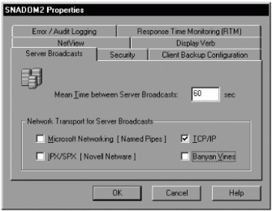
Figure 13.27: Subdomain Properties, Server Broadcasts Tab.
See full-sized image.
Troubleshooting SNA Server Client-to-SNA Server Communications
One of the most common causes of SNA Server connectivity problems is due to errors with SNA Server client-to-SNA Server communications. This is probably due to the fact that there are typically a lot more SNA Server clients in an organization than there are SNA Servers or hosts. Odds are you will be troubleshooting clients quite a bit. Because of this, it is important that we understand some of the problems that may arise with client-to-server communications and what we can do about them.
Chapter 8, "Installing and Configuring SNA Server Client Communications," described the importance of the sponsor connection process and how clients can access subdomain resource information through their sponsor server. One of the most common problems in client-to-server communications is a client's inability to locate a server and, because of it, its inability to establish a sponsor connection. When this happens, a number of errors could appear on the SNA Server client computer, depending on why the client is not locating the server and why it cannot establish a sponsor connection. The common causes for these errors are:
• | The network is down. Verify if this is the case by simply trying to access any network resource from at least two separate computers on the network.
• | The client's network adapter is malfunctioning. You can verify this by confirming that you cannot access any network resources from the client computer while other network computers can access network resources. Figure 12.28 displays an error 1101, caused on a Windows 95 SNA Server client, which typically indicates problems with the network.  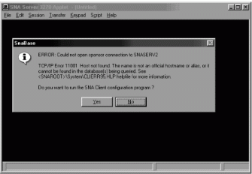  Figure 13.28: Error 1101.  See full-sized image.
• | The client is configured as a local client and is trying to broadcast through network routers that are filtering the broadcasts. Figure 13.29 displays an error 121, which is often indicative of this type of problem. This was caused by a Windows 95 SNA Server client trying to access an SNA Server.  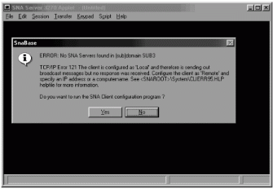  Figure 13.29: Error 121.  See full-sized image.
• | There is a protocol mismatch between the client and the SNA Server. In order for the SNA Server client to communicate with the SNA Server, both client and server must be configured to use the same client/server protocol.
• | The SNA Server might be malfunctioning.
• | The client may not have access rights to the SNA Server, which would prevent establishment of a sponsor connection and accessing resource information.
When using 16-bit SNA Server clients, such as Windows 3.x or Windows for Workgroups, the 546 error is very common. Error 546 indicates that the client was not able to establish a sponsor connection; which may be due to any of the causes listed above. For NetWare or Vines clients, it is also important to check whether you receive an error 629 prior to receiving the 546. Error 629 indicates that the client could not obtain SNA Server names from the NetWare or Vines server, which may indicate a problem with accessing the NetWare or Vines server. If a 629 error does not appear, the indication would be that the SNA Server is able to obtain SNA Server names, but is not able to access the SNA Server for any of the reasons listed above.
One other problem that may occur with client-to-server communications is the inability to get third-party emulators to work properly. For this reason, SNA Server includes the 3270 and 5250 Applets that can be used to test an existing client-to-server configuration. For example, if a third-party 3270 emulator is not functioning, you can use the SNA Server 3270 Applet to test the configuration. If the 3270 Applet works fine, this would indicate a configuration problem specific to the third-party software. If, however, the 3270 Applet does not work properly, you have to check the existing client and server configurations.
Troubleshooting Tools
There may be some cases where even the most diligent research does not yield the information necessary to find the cause of the problem. I'm sure you've come across these before. In such cases, it may be useful to employ some of the troubleshooting tools included with SNA Server. These tools are the event message database and the tracing tool. The event message database is a database of all of SNA Server events. This can be very useful when troubleshooting problems, since most events listed in the database provide full explanations as to their cause and what can be done to fix them.
The database is located on the SNA Server CD-ROM in the \Docs\Msgdb subdirectory. The database file name is Snamsg.mdb. There is also an event message database in this same directory which lists all of the events related to COMTI. The COMTI event message database name is Comtimsg.mdb. These databases can be viewed with any copy of Microsoft Access 95 (or later). You can also use the Dbview.exe utility located in this same directory. You can use Access or the viewer utility to search the entire database in order to find information on the cause of the problem.
The other troubleshooting tool that can be used is the tracing tool. Although it is simple to generate trace files, it is another thing to be able to interpret those files to be able to find the source of the problems.
Using the Tracing Utility to Locate Problem Sources
Perhaps the most powerful tool used in troubleshooting SNA Server communications is the tracing utility. SNA tracing is a method by which communications within an SNA environment can be recorded to a trace file. This trace file can then be interpreted to determine the cause of any given SNA Server error. The difficulty comes with the fact that these trace files depict exactly what is going on between or within devices, so that, in order to understand the information depicted in trace files, you must have a thorough understanding of SNA communications or SNA Server internals. More often than not this sort of understanding is beyond the reach of SNA Server administrators. SNA Server administrators, therefore, often depend on the services of other engineers who have the required expertise. Many of the recorded trace files will typically be sent to technical support staffs at Microsoft or IBM.
Even though it is likely that others will be responsible for actually reading the trace file and interpreting its contents, it is still an SNA Server administrator's responsibility to be able to generate a trace file. To record information to a trace file, you must perform the following steps:
1. | Determine what to trace—The first step in troubleshooting a problem using tracing is to determine what SNA Server components need to be traced.
2. | Use the SNA Server trace utility to generate the trace—This utility allows you to select the components to trace and is responsible for actually recording the communications to a file.
Help from SNA communications engineers is often required to determine what SNA Server components need to be traced. You might call on IBM of Microsoft for technical support and, if they can't resolve your issue with other methods, they may resort to tracing. Often, in such cases, the support personnel will tell you exactly what components need to be traced. Throughout this section, we describe some of these components so that you also have an understanding of what types of tracing can be done and what components can be traced.
The tool used to generate traces with SNA Server is the SNA trace utility. To generate a trace file using this utility, you must complete the following steps on the SNA Server manager:
1. | On the Tools menu, select Trace. The Trace Settings window, Trace Items tab appears, as shown in Figure 13.30. This window contains a list of all the components that can be traced. This includes almost every component of SNA Server, such as link services, SNA applications, TN3270, etc.  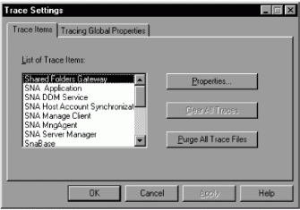  Figure 13.30: Trace Settings Window, Trace Items Tab.  See full-sized image.
2. | The trace utility treats SNA Server software components as items, so you must select the item to trace and click the Properties button. The Trace Properties Sheet window appears and, depending on the item being traced, this window may have one or as many as four tabs on which you can configure trace properties. The most common tabs are the Internal Trace, the Message Trace, and the API tabs. The properties included in each of these properties are described in the next three sections.
3. | After selecting the proper trace properties, click OK to return to the Trace Settings window.
4. | To enable tracing, click OK on the Trace Settings window. A message appears, as shown in Figure 13.31, with a warning that tracing can degrade system performance. Click Yes to continue.  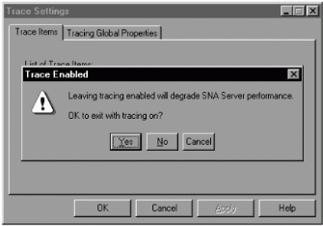  Figure 13.31: Warning Message.  See full-sized image.
Trace files created by the SNA Server trace utility are saved with a .TRC extension in the \[Snaroot]\Traces directory.
Configuring the Trace Properties on the Internal Trace Tab
Internal tracing can trace the activity within an SNA Server component. Figure 13.32 depicts the Internal Trace tab of the Trace Properties Sheet window. This type of tracing usually yields information regarding the internal functions of an SNA Server component, such as error conditions that may be causing the component itself to fail. Table 13.5 defines each of the internal trace types that can be configured.
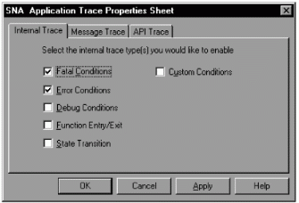
Figure 13.32: Trace Properties Sheet, Internal Trace Tab.
See full-sized image.
Table 13.5 Trace Property Sheet Window, Internal Trace Tab
Property | Definition
Fatal Conditions | This allows you to trace transaction programs (TPs) that experience an error condition that stops TP execution.
Error Conditions | This allows you to see what is causing error conditions that are non-fatal—in other words, you can see conditions that do not necessarily cause the process to abort.
Debug Conditions | This produces trace files that allow you to analyze performance issues and view diagnostic information.
Function Entry/Exit | This allows you to focus on a subroutine within a program.
State Transition | This allows you to track the states during a module's execution.
Configuring the Trace Properties on the Message Trace Tab
Message tracing can trace the messages used in communications between SNA Server components and other SNA components on the network. The type of message tracing that can be done differs depending on which item you are tracing. Figure 13.33 depicts the Message Trace tab of the Trace Properties Sheet window and Table 13.6 provides a definition for each type of message tracing available.
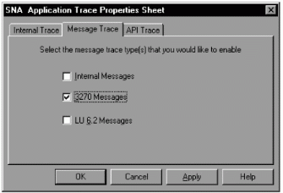
Figure 13.33: Trace Properties Sheet, Message Trace Tab.
See full-sized image.
Table 13.6 Trace Property Sheet Window, Message Trace Tab
Property | Definition
Internal Messages | This allows you to list internal messages for the item being traced.
3270 Messages | This allows you to trace messages between 3270 applications and the SNA Server (PU 2.1 node).
LU 6.2 Messages | This allows you to trace messages between the SNA Server (PU 2.1 node) and the APPC DLL.
Data Link Control | This allows you to trace messages between the SNA Server (PU 2.1 node) and link services.
SNA Formats | This allows you to trace data link control messages that are in SNA formats.
Level 2 Messages | This allows you to trace messages related to Level 2 in the International Standards Organization (ISO) model and OSI model.
Configuring the Trace Properties on the API Trace Tab
API tracing can trace information between the API DLL provided by SNA Server and the application using that API DLL. Figure 13.34 depicts the API Trace tab of Trace Properties Sheet window and Table 13.7 provides a definition for each type of message tracing available.
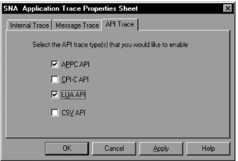
Figure 13.34: Trace Properties Sheet, API Trace Tab.
See full-sized image.
Table 13.7 Trace Property Sheet Window, API Trace Tab
Property | Definition
APPC API | This allows you to trace activity between APPC applications and the APPC DLL on SNA Server.
CPI-C API | This allows you to trace activity between CPI-C applications and the CPI-C DLL on SNA Server.
LUA API | This allows you to trace activity between the LUA API and the LUA DLL on SNA Server.
CSV API | This allows you to trace activity between CSV applications and the CSV DLL on SNA Server.
Setting Global Tracing Properties
There are a few tracing properties that apply to all trace items. Two of these properties appear on the Trace Items tab of the Trace Settings window (see Figure 13.29). The Clear All Traces button can be used to clear all traces that you may have previously configured. This is very useful since it can sometimes be very difficult to remember which item you may have enabled for tracing. The Purge All Trace Files button can be used to delete all existing trace files. To configure the rest of the global properties, you must access the Trace Global Properties tab in the Trace Settings window, as shown in Figure 13.35. Table 13.8 provides a definition for each of these properties.
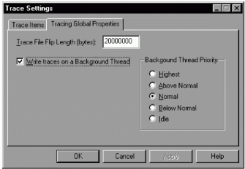
Figure 13.35: Trace Settings Window, Global Properties Tab.
See full-sized image.
Table 13.8 Trace Settings Window Global Tracing Properties
Property | Definition
Trace File Flip Length | This property determines the size of the tracing file. The default file size is 20,000,000 bytes. Each trace generated with the trace utility can have up to two files associated with it. The first file is used to write the trace information until its file flip length limit is reached. At this point, the trace information is written to a second file. If the file limit is reached on the second file, the trace utility returns to the first file to record trace information and this first file's initial contents are overwritten.
Write Traces on a Background Thread | Windows NT applications can be configured with different execution priority. In other words, some applications can be given more priority when trying to gain access to the processor than other applications. Selecting this property runs tracing on a Windows NT background thread. If this property is unchecked, tracing will run on the foreground. Running tracing on the foreground gives the application high priority. It is typically best to run tracing on a background thread. This is the default.
Background thread Priority | When selecting tracing to run in the background, you can configure the thread priority using this property. You must pay close attention to this property since tracing, especially if given higher thread priorities, can degrade the performance of your SNA Server.
Highest | Setting this option provides tracing with priority over most other jobs.
Above Normal | Setting this option gives tracing a bit more priority than other Windows NT threads.
Normal | Setting this option puts tracing somewhere on the par with most other jobs. This is the default setting.
Below Normal | Setting this option gives tracing a bit less priority than other Windows NT threads.
Idle | Setting this option allows tracing to take place only when the processor is not busy.
After the trace file is generated, you can view the file using the trace viewer. Selecting Trace Viewer on the SNA Server Manager's tools menu accesses the trace viewer. Figure 13.36 depicts a typical trace viewer window.
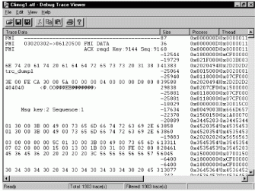
Figure 13.36: Trace Viewer Window.
See full-sized image.
You can also generate trace files using the SNA Server client. The 32-bit clients, such as the Windows 95 and Windows NT clients, use the same tracing tool as used by SNA Server. The other SNA Server clients use a client-specific method for generating traces. The SNA Server online documentation provides information on generating trace files using SNA Server clients.
Top of page

Study Break

Using the Trace Utility Even Without Access to a Host
As with the performance monitor, you can use the tracing utility to trace SNA Server communications, even if you are not actually accessing a host computer. To do so, all you need to do is follow the instructions provided in previous chapters for configuring any type of SNA Server demo access. In other words, configuring SNA Server when no host is available, such as configuring 3270 access or 5250 access using the demo SDLC link service. After properly configuring demo access, you can use the trace utility to trace the type of communications that you've configured. This does not provide you with accurate and complete trace readings, since you're not actually accessing a host, but it does give you an idea of how the trace utility works and the type of information that it generates.
Top of page

Summary
This chapter described the importance of SNA Server maintenance. Even after all the configuring is done, SNA Server administrators must pay close attention to SNA Server functions in order to ensure the server's proper maintenance. SNA Server maintenance is very important because the SNA Server is often entrusted with providing clients with access to an organization's most mission-critical data. SNA Server administrators can employ management tools used to manage SNA Server from the host as well as tools used for performance tracking and troubleshooting, such as the tracing utility.

Managing SNA Server
This section described the tools used for SNA Server management. The following SNA Server tools can be used to manage SNA Server:
• | NVAlert and NVRuncmd services—These services are used to provide maintenance information to the host's NetView management software, as well as to allow NetView operators to execute Windows NT commands from the NetView console. The NVAlert service intercepts events logged to the Windows NT event log and forwards those events to the NetView console operator. NVAlert only forwards those events that are specified in the NVAlert.ini file. NVRuncmd allows NetView console operators to run Windows NT commands on the SNA Server computer.
• | Windows NT event logging—This tool can be used with all aspects of SNA Server maintenance. SNA Server and its services constantly log information to the event log subsystem in order to provide information regarding its function. This information can be informative, it may describe an impending problem, or it may provide troubleshooting information required for resolving an existing problem. SNA Server logs most of its event information to the applications log. The system and security event logs also contain useful events that can be used to manage SNA Server. SNA Server events can be routed to one central SNA Server in a subdomain for easier administration.
• | Pop-up message—SNA Server is also capable of displaying pop-up messages in order to convey a maintenance-related message to the SNA Server administrator. Pop-up messages from multiple SNA Servers can be routed to a single Windows NT computer for easier administration. SNA Server pop-up messages can be routed to one central SNA Server in a subdomain for easier administration.
• | SnaRas service—This service provides a means by which SNA Server administrators can use client/server protocols over an SNA protocol link. This can be useful when managing remote SNA Servers. To configure SnaRas, you must configure an SnaRas client, an access SNA Server, and an SnaRas server. SnaRas is an APPC application that uses SNA Server's link service, connections, and APPC LUs to establish client/server communications over an SNA-only link.
• | Snacfg utility—This command-line utility allows SNA Server administrators to configure SNA Server from the command line as opposed to using the SNA Server manager. Even though it is recommended that you use the SNA Server manager for configuration, this tool can be very useful in certain circumstances. Snacfg can be used in many different situations, such as when the SNA Server manager is not easily accessible or when configuring an offline configuration file.
Tracking and Improving SNA Server Performance
This section describes some of the tools that can be used to gauge SNA Server performance and some of the ways to configure SNA Server in order to improve performance. The following tools and methods can be used for tracking and improving SNA Server performance:
• | Performance Monitor—This is a Windows NT tool that can be used to track almost every aspect of Windows NT performance, as well as SNA Server performance. This can be very useful when establishing an SNA Server performance baseline or when trying to locate a performance problem. Objects, counters, and instances are used to specify which components to measure.
• | Response Time Monitor (RTM)—This tool provides a way to measure host response times, including the time required for an SNA Server client's message to reach the host and for the host to respond. RTMs must be supported by the client's 3270 emulator or else SNA Server cannot collect RTM information. A typical host response should take no more then two seconds.
• | Multinode Support—SNA Server allows you to configure as many as four SNA Server services for each SNA Server installation. This is sort of like running four copies of SNA Server on one computer. This can help in two ways. First, it increases by a factor of four, if that many services are running, the number of LUs and other resources that can be configured on SNA Server. Second, it can provide a performance improvement by dividing SNA Server functions over as many as four different SNA Services, all of which have equal priority access to system resources.
• | Data Compression—This SNA Server capability can be employed with many of the SNA Server configurations. Compressing SNA Server data prior to transmission aids in conserving network bandwidth, although it does demand more time and resources from the local computers that are required to compress and decompress data before it is transmitted or consumed.
Basic transmission unit (BTU) size determines the number of bytes that an SNA data link frame can carry. You must adjust this property to ensure the best performance. The pacing window must also be set correctly in order to achieve the best use of the network bandwidth. Finally, request/response unit size defines the amount of useful data to be carried in an SNA data-link frame.
Troubleshooting SNA Server Communications
This section described some of the tools and techniques that can be used _to troubleshoot SNA Server faults. Various problems could arise in SNA Server-to-host communications, SNA Server-to-SNA Server communications, and SNA Server client-to-SNA Server communications, so you must employ different methods and tools to troubleshoot those problems. You can use the event message database that ships with SNA Server. The database provides a listing of all events generated by SNA Server along with an explanation of each. The SNA tracing utility can also be used to further troubleshoot problems by allowing you to record activity between SNA Server and any other node on the SNA network.
Review Questions
1. | What can be used to forward SNA Server alerts to the NetView console?
2. | What text file contains the information specifying which alert events to forward to the Netview console?
3. | Where would you specify the connection on which alerts will be sent to Netview?
4. | What service allows a Netview console operator to run a command at the Windows NT Server?
5. | True or false? Only alphanumeric characters can be sent back to the Netview console and no graphical content can be sent to the Netview console.
6. | What feature of SNA Server allows administrators to manage branch SNA Servers over an SNA-only WAN link?
7. | What command line utility allows you to configure almost everything in SNA Server?
8. | True or false? Prior to running the Snacfg program for the first time, you must run the SNA Server Manager program at least once.  A command file is typically saved using what filename extension?
  1. | .txt
  2. | .ext
  3. | .cmd
  4. | .bat
9. | True or false? When SNA Server is installed, it adds its own sets of objects, counters, and instances to the performance monitor.
10. | What property specifies the maximum number of bytes that can be transported in a single data link frame?
11. | When configuring for multinode support, how many nodes (SNA Server services) can exist on a single computer?
12. | What is used to monitor the time required for the host to respond to 3270 client requests?
13. | True or false? Any RTM configurations made at the SNA Server will override RTM settings configured on a host.
14. | True or false? You can configure compression between two SNA Servers communicating over a WAN using the distributed link service.
15. | Where can you specify the protocols to use for SNA Server-to-SNA Server broadcasts over the subdomain?  Which of the following components can be traced using the SNA Server trace utility?
  1. | SNA Server Manager
  2. | SnaBase
  3. | SNA applications
  4. | All of the above
Copyright © 1998 by Prentice Hall, PTR<http://www.prenticehall.com>
We at Microsoft Corporation hope that the information in this work is valuable to you. Your use of the information contained in this work, however, is at your sole risk. All information in this work is provided "as -is", without any warranty, whether express or implied, of its accuracy, completeness, fitness for a particular purpose, title or non-infringement, and none of the third-party products or information mentioned in the work are authored, recommended, supported or guaranteed by Microsoft Corporation. Microsoft Corporation shall not be liable for any damages you may sustain by using this information, whether direct, indirect, special, incidental or consequential, even if it has been advised of the possibility of such damages. All prices for products mentioned in this document are subject to change without notice. International rights = English only.

